**Project - 1**

**Aim: Write a dart program to print all negative elements in an array.**

**Program:**

import 'dart:io';

void main() {

var a = [];

int c = 0;

stdout.write("* How many elements :- ");

int n = int.parse(stdin.readLineSync()!);

print("\n* Enter array elements :- ");

for (int i = 0; i < n; i++) {

a.add(int.parse(stdin.readLineSync()!));

}

print("\n=> All negative elements :- ");

for (int i = 0; i < n; i++) {

if (a[i] < 0) {

print(a[i]);

} else {

c++;

}

}

if (c == 0) {

print("\n- No negative elements in this array...\n");

}

}

**Output:**

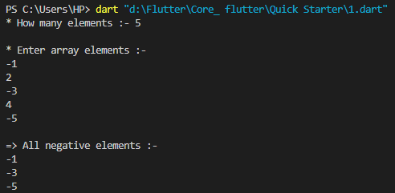

**Project - 2**

**Aim: Write a dart program to find largest number in an array.**

**Program:**

import 'dart:io';

void main() {

var a = [];

stdout.write("* How many elements :- ");

int n = int.parse(stdin.readLineSync()!);

print("\n* Enter array elements :- ");

for (int i = 0; i < n; i++) {

a.add(int.parse(stdin.readLineSync()!));

}

stdout.write("\n=> Largest number in an array :- ");

for (int i = 0; i < n; ++i) {

if (a[0] < a[i]) {

a[0] = a[i];

}

}

print(a[0]);

print("\n");

}

**Output:**

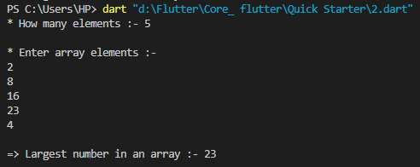

**Project - 3**

**Aim: Write a dart program to Insert, Delete, Update and View operations on the elements in an array using menu-driven programming approach.**

**Program:**

import 'dart:io';

void main() {

var a = [];

int x, y;

stdout.write("* How many elements :- ");

int n = int.parse(stdin.readLineSync()!);

print("\n* Enter array elements :- ");

for (int i = 0; i < n; i++) {

a.add(int.parse(stdin.readLineSync()!));

}

print("\n=> Press 1 for Insert.");

print("=> Press 2 for Delete.");

print("=> Press 3 for Update.");

print("=> Press 4 for View.");

stdout.write("\n* Enter your choice :- ");

int choice = int.parse(stdin.readLineSync()!);

switch (choice) {

case 1:

stdout.write("\n* Enter index number for Insert :- ");

x = int.parse(stdin.readLineSync()!);

stdout.write("\n* Enter element for Insert :- ");

y = int.parse(stdin.readLineSync()!);

a.insert(x, y);

print("\n$a\n");

break;

case 2:

stdout.write("\n* Enter position for Delete element :- ");

x = int.parse(stdin.readLineSync()!);

a.remove(x);

print("\n$a\n");

break;

case 3:

stdout.write("\n* Enter index number for Update element :- ");

x = int.parse(stdin.readLineSync()!);

stdout.write("\n* Enter element for Update element :- ");

y = int.parse(stdin.readLineSync()!);

a.forEach((val) {

val = x;

a[x] = y;

});

print("\n$a\n");

break;

case 4:

stdout.write("\n* Enter index number for view element :- ");

x = int.parse(stdin.readLineSync()!);

print("\n${a[x]}\n");

break;

default:

print("\n=> Invalid Choice....\n");

break;

}

}

**Output:**

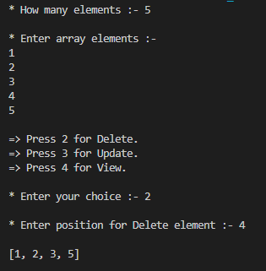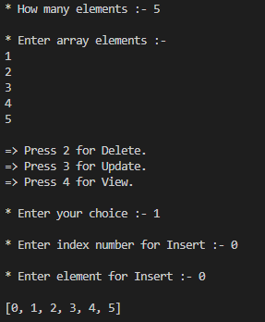

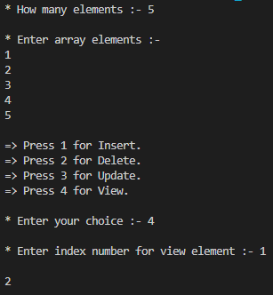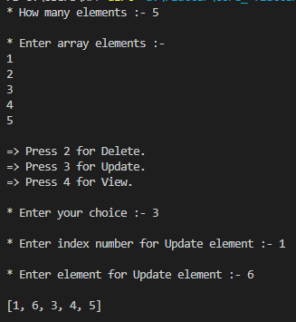

**Project - 4**

**Aim: Write a Dart program to addition of two matrices of dimension 3*3.**

**Program:**

import 'dart:io';

void main() {

int n = 3;

int m = 3;

print("* Enter elements of a array 3*3 :- ");

var a = List.generate(

n, (i) => List.generate(m, (j) => int.parse(stdin.readLineSync()!)));

print(a);

print("\n* Enter elements of b array 3*3 :- ");

var b = List.generate(

n, (i) => List.generate(m, (j) => int.parse(stdin.readLineSync()!)));

print(b);

print("\n=> Addition of both matrix :- ");

var c = List.generate(n, (i) => List.generate(m, (j) => a[i][j] + b[i][j]));

print(c);

}

**Output:**

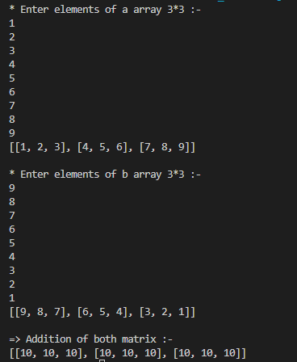

**Project - 5**

**Aim: Write a Dart program to find below mentioned operations on the 3x3 array.**

**using a menu-driven programming approach.**

**Perform below all mentioned by user choice:**

**• Sum of all elements**

**• Sum of specific Row**

**• Sum of specific Column**

**• Sum of diagonal elements**

**• Sum of antidiagonal elements**

**• Press 0 for exit**

**Program:**

import 'dart:io';

void main() {

int ch;

int n = 3;

int m = 3;

int sum = 0;

int r = 0;

do {

stdout.write("""\n\n\n

Press 1 for Sum of all elements.

Press 2 for Sum of specific row.

Press 3 for Sum of specific column.

Press 4 for Sum of diagonal elements.

Press 5 for Sum of antidiagonal elements.

Press 0 for Exit :- """);

stdout.write("\n* Enter your choice :- ");

ch = int.parse(stdin.readLineSync()!);

switch (ch) {

case 0:

break;

case 1:

print("\n=> Enter matrix 3*3 :- ");

var ascList = List.generate(n,

(i) => List.generate(m, (j) => int.parse(stdin.readLineSync()!)));

print(ascList);

stdout.write("\n\n=> Sum of all elements are :- ");

var bList = List.generate(

n, (i) => List.generate(m, (j) => sum = sum + ascList[i][j]));

stdout.write(sum);

break;

case 2:

stdout.write("\n=> Enter matrix 3*3 :-");

var ascList = List.generate(n,

(i) => List.generate(m, (j) => int.parse(stdin.readLineSync()!)));

print(ascList);

stdout.write("\n\nsum of rows ::");

int i = int.parse(stdin.readLineSync()!);

var bList = List.generate(

n, (i) => List.generate(m, (j) => r += ascList[i][j]));

for (int i = 0; i < n; i++) {

for (int j = 0; j < n; j++) {

sum += ascList[i][j];

r += ascList[i][j];

}

print("sum of ${i + 1} row is $r ");

}

break;

case 3:

stdout.write("enter matrix 3*3 ::");

var ascList = List.generate(n,

(i) => List.generate(m, (j) => int.parse(stdin.readLineSync()!)));

print(ascList);

stdout.write("\n\nsum of coloumns ::");

int i = int.parse(stdin.readLineSync()!);

var bList = List.generate(

n, (i) => List.generate(m, (j) => r += ascList[i][j]));

for (int i = 0; i < n; i++) {

for (int j = 0; j < n; j++) {

sum += ascList[i][j];

r += ascList[j][i];

}

print("sum of ${i + 1} column is $r ");

}

break;

case 4:

stdout.write("enter matrix 3*3 ::");

var ascList = List.generate(n,

(i) => List.generate(m, (j) => int.parse(stdin.readLineSync()!)));

print(ascList);

stdout.write("\n\nSum of diagonal elements are :: ");

var bList = List.generate(

n,

(i) => List.generate(

m, (j) => (i == j) ? {sum += ascList[i][j]}! : {" "}));

for (int i = 0; i < n; i++) {

for (int j = 0; j < n; j++) {

if (i == j) {

sum += ascList[i][j];

}

}

}

stdout.write(sum);

break;

case 5:

stdout.write("enter matrix 3*3 ::");

var ascList = List.generate(n,

(i) => List.generate(m, (j) => int.parse(stdin.readLineSync()!)));

print(ascList);

stdout.write("\n\nSum of diagonal elements are :: ");

var bList = List.generate(

n,

(i) => List.generate(

m, (j) => (i == j) ? {sum += ascList[i][j]}! : {" "}));

for (int i = 0; i < n; i++) {

for (int j = 0; j < n; j++) {

if (i + j == 2) {

sum += ascList[i][j];

}

}

}

stdout.write(sum);

break;

default:

stdout.write("Put valid choice :::");

}

} while (ch != 0);

}

**Output:**

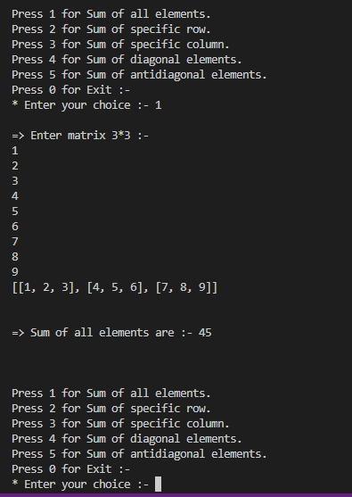

**Task- 1**

**Aim: Create an app as shown in below image.**

**Program:**

import 'package:flutter/material.dart';

void main() {

runApp(

MaterialApp(

debugShowCheckedModeBanner: false,

home: Scaffold(

appBar: AppBar(

title: const Text(" 🛍 List of Fruits"),

centerTitle: true,

backgroundColor: Colors.teal,

titleTextStyle: const TextStyle(

fontSize: 25,

fontWeight: FontWeight.bold,

letterSpacing: 2,

),

),

body: Center(

child: RichText(

text: const TextSpan(

text: "🍎 Apple\n",

style: TextStyle(

fontSize: 35,

color: Colors.red,

height: 1.5,

fontWeight: FontWeight.bold,

letterSpacing: 3,

),

children: [

TextSpan(

text: "🍇 Greps\n",

style: TextStyle(

color: Colors.purpleAccent,

),

),

TextSpan(

text: "🍒 Cherry\n",

style: TextStyle(

color: Colors.purple,

),

),

TextSpan(

text: "🍓 Strawberry\n",

style: TextStyle(

color: Colors.pinkAccent,

),

),

TextSpan(

text: "🥭 Mango\n",

style: TextStyle(

color: Colors.amber,

),

),

TextSpan(

text: "🍍 Pineapple\n",

style: TextStyle(

color: Colors.green,

),

),

TextSpan(

text: "🍋 Lemon\n",

style: TextStyle(

color: Colors.amberAccent,

),

),

TextSpan(

text: "🍉 Watermelon\n",

style: TextStyle(

color: Colors.lightGreen,

),

),

TextSpan(

text: "🥥 Coconut\n",

style: TextStyle(

color: Colors.brown,

),

),

]),

),

),

),

),

);

}

**Output:**

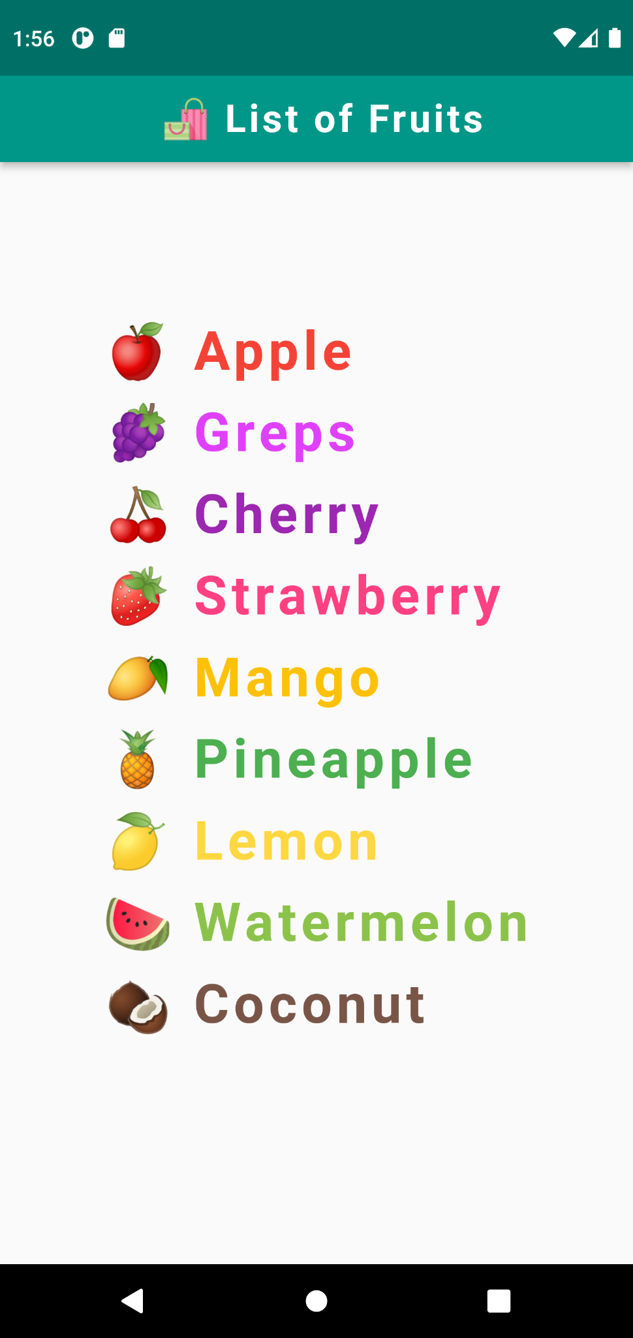

**Task- 2**

**Aim: Create an app as shown in below image.**

**Program:**

import 'package:flutter/material.dart';

void main() {

runApp(

MaterialApp(

debugShowCheckedModeBanner: false,

home: Scaffold(

backgroundColor: Colors.black,

appBar: AppBar(

title: const Text("Red & White"),

centerTitle: true,

backgroundColor: Colors.red,

),

body: Center(

child: RichText(

text: const TextSpan(

text: " G",

style: TextStyle(

fontSize: 28,

color: Colors.green,

fontWeight: FontWeight.bold,

letterSpacing: 5,

height: 1.5,

),

children: [

TextSpan(

text: "R",

style: TextStyle(

fontSize: 36,

color: Colors.red,

),

),

TextSpan(

text: "APHICS\n",

style: TextStyle(

fontSize: 28,

color: Colors.green,

),

),

TextSpan(

text: " FLUTT",

style: TextStyle(

fontSize: 28,

color: Colors.blue,

),

),

TextSpan(

text: "E",

style: TextStyle(

fontSize: 36,

color: Colors.red,

),

),

TextSpan(

text: "R\n",

style: TextStyle(

fontSize: 28,

color: Colors.blue,

),

),

TextSpan(

text: " AN",

style: TextStyle(

fontSize: 28,

color: Colors.green,

),

),

TextSpan(

text: "D",

style: TextStyle(

fontSize: 36,

color: Colors.red,

),

),

TextSpan(

text: "ROID\n",

style: TextStyle(

fontSize: 28,

color: Colors.green,

),

),

TextSpan(

text: "DESIGN",

style: TextStyle(

fontSize: 28,

color: Colors.amber,

),

),

TextSpan(

text: " &",

style: TextStyle(

fontSize: 36,

color: Colors.red,

),

),

TextSpan(

text: " DEVLOP\n",

style: TextStyle(

fontSize: 28,

color: Colors.amber,

),

),

TextSpan(

text: " W",

style: TextStyle(

fontSize: 36,

color: Colors.red,

),

),

TextSpan(

text: "EB\n",

style: TextStyle(

fontSize: 28,

color: Colors.blue,

),

),

TextSpan(

text: " FAS",

style: TextStyle(

fontSize: 28,

color: Colors.yellow,

),

),

TextSpan(

text: "H",

style: TextStyle(

fontSize: 36,

color: Colors.red,

),

),

TextSpan(

text: "ION\n",

style: TextStyle(

fontSize: 28,

color: Colors.yellow,

),

),

TextSpan(

text: " ANIMAT",

style: TextStyle(

fontSize: 28,

color: Colors.teal,

),

),

TextSpan(

text: "I",

style: TextStyle(

fontSize: 36,

color: Colors.red,

),

),

TextSpan(

text: "ON\n",

style: TextStyle(

fontSize: 28,

color: Colors.teal,

),

),

TextSpan(

text: " I",

style: TextStyle(

fontSize: 28,

color: Colors.blue,

),

),

TextSpan(

text: "T",

style: TextStyle(

fontSize: 36,

color: Colors.red,

),

),

TextSpan(

text: "A-CS+\n",

style: TextStyle(

fontSize: 28,

color: Colors.blue,

),

),

TextSpan(

text: " GAM",

style: TextStyle(

fontSize: 28,

color: Colors.amber,

),

),

TextSpan(

text: "E",

style: TextStyle(

fontSize: 36,

color: Colors.red,

),

),

],

),

),

),

),

),

);

}

**Output:**

